SIMATS ENGINEERING

ASSESSMENT TOOL 2

COURSE NAME: CSA07 COURSE CODE: Computer Networks

COURSE OUTCOME COVERED

CO1: Apply the functions of OSI layer in enabling reliable data transmission across networks. (BL2, BL3)

Assessment Tool Weightage: 30%

Annexure A

CONCEPT MAPPING

Code of Conduct:
I C.Manoj Kumar(192472008)(Name / Reg No) certify that this submission is my original work and that I have adhered to the guidelines specified for this assessment.
I understand that any violation of academic integrity rules will result in disciplinary action.

Signature of the student:

Annexure A

CONCEPT MAPPING

- A partially completed concept map is given below:

Application → Presentation → → Transport → Network → → Physical.

Analyze the missing layers and explain how their functions are essential for reliable communication.

- Construct a concept map linking data units (Segment, Packet, Frame, Bits) with their respective OSI layers and analyze how transformation of data units supports transmission.

- Given the concept map:
DataLink→MACAddress→LocalDelivery Network → IP Address → Global Delivery
Explain how these relationships ensure complete data delivery across networks.

- A concept map shows:
ErrorControl
→DataLinkLayer→ErrorDetection
→ Transport Layer → Error Correction
Analyze how the interaction between these layers improves reliability in data transmission.

- Develop a concept map for web browsing using OSI layers and analyze how failure in one layer affects the entire communication process.

- A network issue is represented in the concept map:
Physical ✔ → Data Link ✔ → Network ✖ → Transport ✖ → Application ✖
Analyze the problem and explain how the concept map helps in troubleshooting.

RUBRICS FOR CALCULATION

Criteria | Weightage (%) | Level 4 (Exemplary) | Level 3 (Proficient) | Level 2 (Developing) | Level 1 (Beginning)
Concept Identification | 20% | Accurately identifies all relevant OSI layers, concepts, and relationships | Identifies most concepts with minor omissions | Identifies limited concepts; some inaccuracies | Unable to identify key concepts correctly
Concept Mapping Structure | 25% | Constructs a clear, logical, and well-organized concept map with proper hierarchy and connections | Concept map is mostly clear with minor structural issues | Concept map lacks clarity, organization, or proper flow | No clear structure or incorrect mapping
Linking & Relationships | 20% | Clearly establishes correct relationships between layers, functions, and processes | Relationships are mostly correct with minor errors | Limited or partially correct relationships | Incorrect or missing relationships
Application & Analysis | 20% | Effectively applies concepts to explain processes (e.g., encapsulation, error control) with strong reasoning | The application is correct but lacks depth in analysis | Basic application with weak explanation | Unable to apply concepts correctly
Explanation & Clarity | 15% | Provides a clear, concise, and well-structured explanation supporting the  concept map | Explanation is understandable with minor gaps | Explanation is unclear or incomplete | No clear or meaningful explanation

1.A partially completed concept map is given below:

Application → Presentation → → Transport → Network → → Physical.

Analyze the missing layers and explain how their functions are essential for reliable communication.
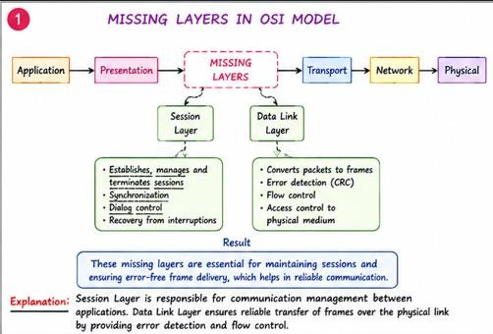

EXPLANATION
- The missing layers are Session Layer and Data Link Layer.
- Session Layer establishes communication between devices.
- It manages and terminates communication sessions.
- It provides synchronization and recovery during failures.
- Data Link Layer converts packets into frames.
- It performs error detection using CRC.
- It provides flow control for reliable transmission.
- These layers ensure reliable and error-free communication.

- Construct a concept map linking data units (Segment, Packet, Frame, Bits) with their respective OSI layers and analyze how transformation of data units supports transmission.

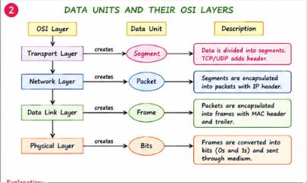

EXPLANATION

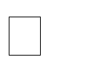




User data starts at the Application Layer. Transport Layer converts data into Segments. Network Layer converts segments into Packets. Data Link Layer converts packets into Frames. Physical Layer converts frames into Bits.

This process is called Encapsulation.

It enables secure and reliable data transmission.

- Given the concept map:
DataLink→MACAddress→LocalDelivery Network → IP Address → Global Delivery
Explain how these relationships ensure complete data delivery across networks.

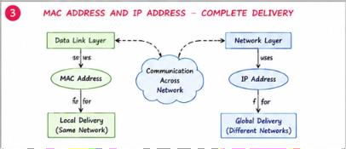

EXPLANATION

  - MAC Address is used by the Data Link Layer.
  - It identifies devices within the same local network.
  - IP Address is used by the Network Layer.
  - It identifies devices across different networks.
  - MAC Address provides Local Delivery.
  - IP Address provides Global Delivery.
  - Together they ensure complete end-to-end communication.

4.A concept map shows: ErrorControl
→DataLinkLayer→ErrorDetection
→ Transport Layer → Error Correction
Analyze how the interaction between these layers improves reliability in data transmission.

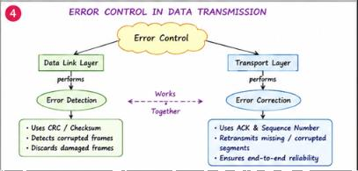

EXPLANATION



Data Link Layer performs Error Detection. It uses CRC or checksum to detect errors.

Transport Layer performs Error Correction.


It uses acknowledgements (ACK) and retransmission. Sequence numbers help identify missing data.


These layers improve communication reliability. They reduce data loss during transmission.

- Develop a concept map for web browsing using OSI layers and analyze how failure in one layer affects the entire communication process.

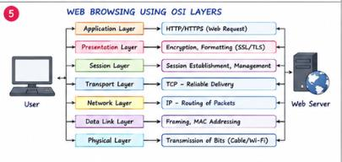

EXPLANATION
  - Application Layer sends HTTP/HTTPS requests.
  - Presentation Layer encrypts and formats data.
  - Session Layer manages the communication session.
  - Transport Layer provides reliable delivery using TCP.
  - Network Layer routes packets using IP addresses.
  - Data Link Layer creates frames using MAC addresses.
  - Physical Layer transmits bits through the network.
  - Failure of any layer interrupts web browsing.

A network issue is represented in the concept map:
Physical ✔ → Data Link ✔ → Network ✖ → Transport ✖ → Application ✖

Analyze the problem and explain how the concept map helps in troubleshooting
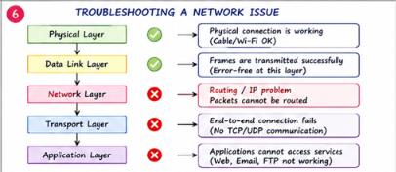

EXPLANATION

- Physical Layer is working correctly.
- Data Link Layer is functioning properly.
- Network Layer has failed due to routing or IP issues.
- Transport Layer cannot establish communication.
- Application Layer services stop working.
- The concept map helps identify the failed layer.
- Troubleshooting should begin with the Network Layer.
- This reduces troubleshooting time and improves network maintenance.

